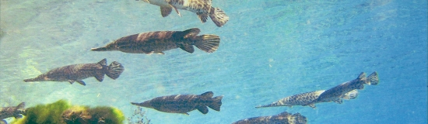

Aquarena Springs Field Trip!!

Dear Parents,

Third grade has scheduled a field trip on **Wednesday, May 15th**, to visit Aquarena Springs. We have planned this to coincide with our unit on the wetlands. During our trip, we will see wetland habitats and animals we will be studying.

The cost of the trip is **$6.50** per student. Please send this money **(cash, only, please!)** and the permission slip to school with your child by **Tuesday, May 7th**.

We will leave the school around 9:00 and return around 1:30. *Your child will need to bring a sack lunch in a bag that can be thrown away. We will be eating lunch on the bus on the way back from San Marcos.*

We will need two parents per class to help out. If you are interested, please indicate below. We will let you know which parents will be chaperoning by the 10th. The cost for each adult is $7.50 to be brought with you on the day of the trip.

- - - - - - - - - - Please cut here and return bottom portion to school with $6.50 - - - - - - - - - -

Child’s name: ________________________________________

My child has permission to attend the field trip to Aquarena Springs on May 15th.

Parent Signature: _____________________________________

___Yes, I am interested in helping with the field trip.

Parent name: ________________________________________